**Ideation Phase**

**Define the Problem Statements**

|  |  |
| --- | --- |
| Date | 1 October 2022 |
| Team ID | PNT2022TMID07958 |
| Project Name | UNIVERSITY ADMIT ELIGIBILITY PREDICTOR |
| Maximum Marks | 2 Marks |

**Customer Problem Statement Template:**

Create a problem statement to understand your customer's point of view. The Customer Problem Statement template helps you focus on what matters to create experiences people will love.

A well-articulated customer problem statement allows you and your team to find the ideal solution for the challenges your customers face. Throughout the process, you’ll also be able to empathize with your customers, which helps you better understand how they perceive your product or service.

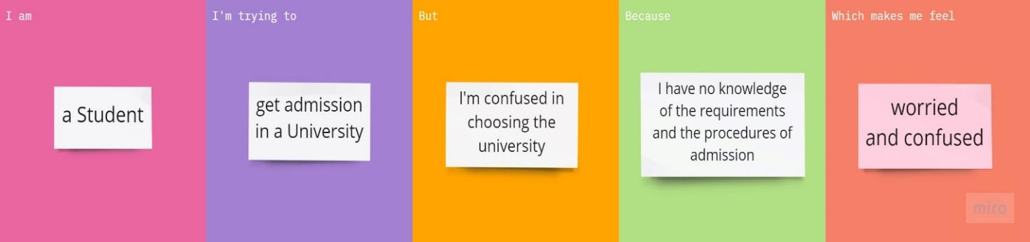

|  |  |  |  |  |  |
| --- | --- | --- | --- | --- | --- |
| **Problem Statement (PS)** | **I am (Customer)** | **I’m trying to** | **But** | **Because** | **Which makes me feel** |
| PS-1 | I’m a Student who wants to get graduate. | I’m trying to get admission in a University | But I’m confused in choosing the University | Because I have no knowledge of the requirements and the procedures of admission. | Worried and Confused. |
| PS-2 | I’m a student searching for the best university. | I’m trying to select which best suits for me. | But I got no proper or complete information from the consultancies and in online blogs. | Because of inaccurate results in online blogs | Depressed and not feeling well |